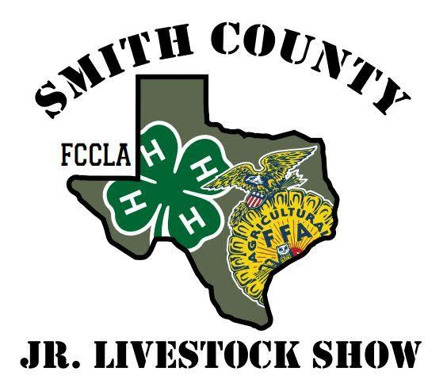

Smith County Junior Livestock Show and Scholarship Fund, Inc.
PO Box 120191
Tyler, Texas 75712
Phone: 903-520-9334
March 27 – March 29, 2024, held at Cross Brand Cowboy Church

Contribution Commitment Form

Yes, we would like to support the Smith County Junior Livestock Show & Scholarship Fund. Below, I have indicated my desired methods of contribution.

Company Name: Contact Name: _________________________________________

Street Address:

City: Zip: Phone: ( )

Fax:( ) Email:

Signature: ____________________________________________________________________________________

Date: ________________________________________________________________________________________

Person who contacted you:________________________________________________________________________

PRESENTING SPONSOR: (1 Available) $15,000
- 10 buyer lunch tickets & VIP buyer’s table
- Company banner at show and Sale of Champions
- Company name and/or logo on marketing material as “SCJLS presented by XXX”
- Company name and/or logo on SCJLS website as Presenting Sponsor
- Individual social media post
- Recognition on program book as “SCJLS presented by XXX”
- Full page ad in program book
- Booth at the event
- Recognition before every show and Sale of Champions

SALE OF CHAMPIONS SPONSOR: (1 Available) $7,500
- 8 Buyer Lunch Tickets & VIP buyer’s table
- Company banner at show and Sale of Champions
- Individual social media post
- Recognition on SCJLS website as Sale of Champions Sponsor
- Full page ad in program book
- Booth at the event
- Recognition before Sale of Champions

FOOD SPONSOR: (1 Available) $5,000
- 5 Buyer lunch tickets & VIP buyer’s table
- Company banner at show and Sale of Champions
- Individual social media post
- Company name and/or logo on SCJLS website as Food Sponsor
- 1/2-page ad in the program book

DIVISION SPONSOR: (10 Available) $3,000
- 5 Buyer Lunch tickets & VIP buyer’s table
- Company banner at designated show and Sale of Champions
- Company name and/or logo on SCJLS website as Division Sponsor
- 1/2-page ad in the program book

FRIEND OF SHOW SPONSOR (Unlimited): $1,000
- 3 Buyer lunch tickets
- Company name and/or logo on SCJLS website as Friend of the Show Sponsor
- 1/4-page ad in the program book

Money raised as sponsorship will help cover specified expenses. Any remaining money will go toward the show’s general fund in the business’s name.

I understand that all financial contributions are tax-deductible. Please indicate desired method and amount of contribution(s):
AMOUNT

SCHOLARSHIP:
- Scholarship Donation to the Smith County Livestock Show Scholarship Fund $__________
Please refer to Scholarship Committee selection criteria for
questions concerning appropriation of scholarship funds.

Donations over $500 will have the following:
- Eighth page ad in our program book as “scholarship sponsor.”
- Company name and/or logo on the sponsor page of SCJLS website.
- Recognition before scholarship presentation at auction

BUYER’S GROUP:
- Buyer’s Group Donation to the Smith County Junior Livestock Show Fund $__________

Donations over $500 will have the following:
- Eighth page ad in our program book as “Buyer’s Group Sponsor.”
- Company name and/or logo on the sponsor page of SCJLS website.
- Recognition before Buyer’s Group raffle drawing at auction

AUCTION:

- Participant Add On Donation: $__________
I would like to donate the following amount to .
Neither my business or myself will be unable to attend the auction,
but would like to contribute this amount to be applied to this participant's project.

- Auction Add On Donation: $__________
I will donate the following amount.
Neither my business or myself will be unable to attend the auction,
but would like to contribute this amount to be evenly distributed among the projects at the Premium Sale.

Contributions over $250 will have their names called during the auction.

ADVERTISEMENT:

- Banner Display ($50.00/day): I would like to purchase signage space for our $__________

Company banner to be displayed during the Smith County Livestock Show.

Banner Information: All banners must be provided by the company and a max size of 3ftx5ft in size. Advertisers will be responsible for delivery and pick-up of their banners to and from the livestock show office on the show grounds. Smith Co. Livestock Show will not be held responsible for damage or loss of any banners. Only advertisements appropriate for youth will be accepted (i.e. alcohol and tobacco ads will not be permitted). Banners provided on time will be displayed in the show arenas and barns, and will be moved to the auction arena on the day of the sale. Location of signage is at the discretion of the Finance Committee.

- Advertisement in Program Book: I would like to an ad $__________

Space for our company name and logo to be displayed in the Smith County Junior Livestock Show program book.

$100.00 Quarter page ad in the program book. Companies are required to provide an ad for approval.
$50.00 Eighth-page ad in the program book. Companies are required to provide an ad for approval.

SHOW SPONSORSHIP:

- Award Sponsorships $__________
Belt buckles are presented to various winners throughout the show. Sponsors of awards are verbally identified upon presentation, and the student receiving the award is given sponsorship information for thank you cards.

  - Belt Buckle sponsorship $150.00

If you desire to sponsor an award for a specific show, please indicate this information below. Sponsorships will be provided on a first come, first served basis, and will otherwise be applied as needed.

IN-KIND CONTRIBUTION / DONATIONS:

I am able to, or have provided, the following services free of charge to the Smith County Livestock Show & Scholarship, Inc. (please add additional page if needed; please complete pertinent information on front)

Amount of Donation:____________________________________________________________________

Use of Donation:________________________________________________________________________

Description of Item:

Total Amount of Contribution Enclosed: $

Commitment forms and payment is due by Friday, March 1, 2024. Sponsorship will not be promoted until payment is made in full. Any sponsorships made after this date are not guaranteed promotion.

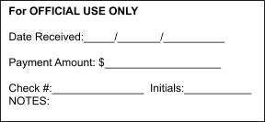
Please mail information and payment to:

Smith County Jr. Livestock Show & Scholarship, Inc. Fundraising Director
PO Box 120191
Tyler, TX 75712

Make checks payable to: Smith County Jr. Livestock Show

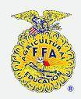
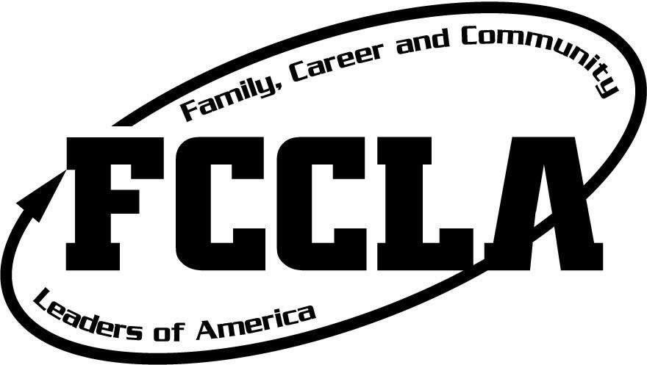
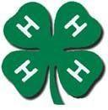
THANK YOU FOR SUPPORTING THE YOUTH OF EAST TEXAS!

